Genesis 2:7 “And YHWH formed man of the dust of the ground, and breathed into his nostrils the breath of life; and man became a living soul.” KJV
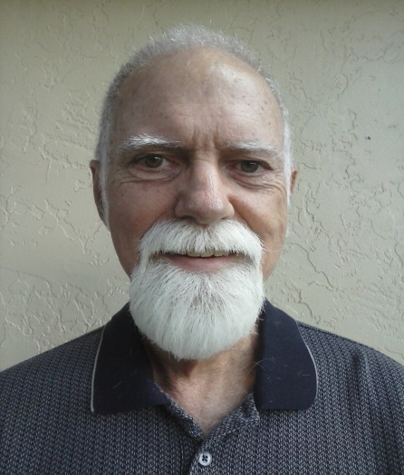
I the free inhabitant Michael Lynch: Freeman, hereinafter “I”, “me”, or “my”, am of sound mind, majority of age, having knowledge and conviction of the facts stated herein, only in the capacity of a free inhabitant and only on YHWH’s soil, jurisdiction and venue, and His time, space, place, plane and law form, do hereby declare and say the following:
- My specific purpose for this Declaration is to establish my identity and valid claim of standing as a free inhabitant with protections and immunities as a matter of Law.
- My photographic likeness is affixed herein.
- My height is approximately six feet one-half inch, weight approximately one hundred and sixty pounds, grey hair, eyes green, and man gender.
- I invoke the Law of YHWH and of Yeshua His only begotten Son Yeshua the Messiah found in the Torah and the Gospels. .
- I am a man made in the image of, and give my allegiance to, YHWH my Father in Heaven, the Giver of the antecedent and ultimate Law to which I adhere, and His only begotten Son Yeshua the Messiah, whom I am commanded to worship and obey above all others.
- Being born on the soil of Georgia, I hereby claim my standing as one of the posterity of the people who formed the several Union States of The United States of America, also known as the perpetual Union and the Confederacy, when the people created and adopted the following: The unanimous Declaration of the thirteen united States of America of July 4, A.D. 1776, and the Articles of Confederation of November 15, A.D. 1777. In the Articles of Confederation, the people granted limited powers of their sovereignty (Article II) to those several Union States styled as The United States of America (Article I). Further, the Declaration (supra) states, in pertinent part, the following: “And for the support of this Declaration, with a firm reliance on the protection of divine Providence, we mutually pledge to each other our Lives, our Fortunes and our sacred Honor.”
- The Articles of Confederation, as current organic law, is presently the only Constitution of the people of The United States of America, limiting both State and federal government.
- My claim of standing is based on Article IV of the Articles of Confederation:
“The better to secure and perpetuate mutual friendship and intercourse among the people of the different States in this Union, the free inhabitants of each of these States…..shall be entitled to all privileges and immunities of free citizens in the several States; and the people of each State shall free ingress and regress to and from any other State…”
- I am one of the people, an heir and beneficiary of that certain Trust known as the Declaration (supra), which all men are “endowed by their Creator with certain unalienable Rights, that among these are Life, Liberty and the pursuit of Happiness.”
I do hereby solemnly declare, and affirm that, in accordance with my knowledge and conviction, the contents hereof are true, correct, complete, not misleading [Qui omne dicit, nihil excludit. He who says all excludes nothing. 4 Inst. 811] and is hereby executed this thirtieth day of the ninth month in the year of our Lord two thousand fourteen [September 30, A.D. 2014] at Marion County, Florida, The United States of America.

____________________________________
Michael Lynch: Freeman

2 Corinthians 13:1”In the mouth of two or three witnesses shall every word be established.” KJV

September 30, A.D. 2014 ____________________________________
Date Witness: Ron Alan
The United States of America

September 30, A.D. 2014 ____________________________________
Date Witness: Vernon Raymond Hastings
The United States of America

September 30, A.D. 2014 ____________________________________
Date Witness: Pamela Kaye: Freeman
The United States of America

“The United States of America” means the collective of the States united by and under the Articles of Confederation of November 15, A.D. 1777, and thereafter, numbering 50 at present, in conformance with the popular and ordinary meaning of the word “States,” i.e., the plural form of the word “State,” as “States” and “State” are used in the Articles of Confederation also known as the perpetual Union and the Confederacy
United States Code (2012 Ed.), Volume 1, Front Matter. See: http://uscode.house.gov/browse/frontmatter/organiclaws

